# MapShareVic

## Overview

Where things exist in Victoria are important facts which help us understand the way things are and help us make informed decisions about future places and management. MapshareVic holds a wealth of spatial data and information which will enable you to compile authoritative maps and tabular data on many themes in Victoria.

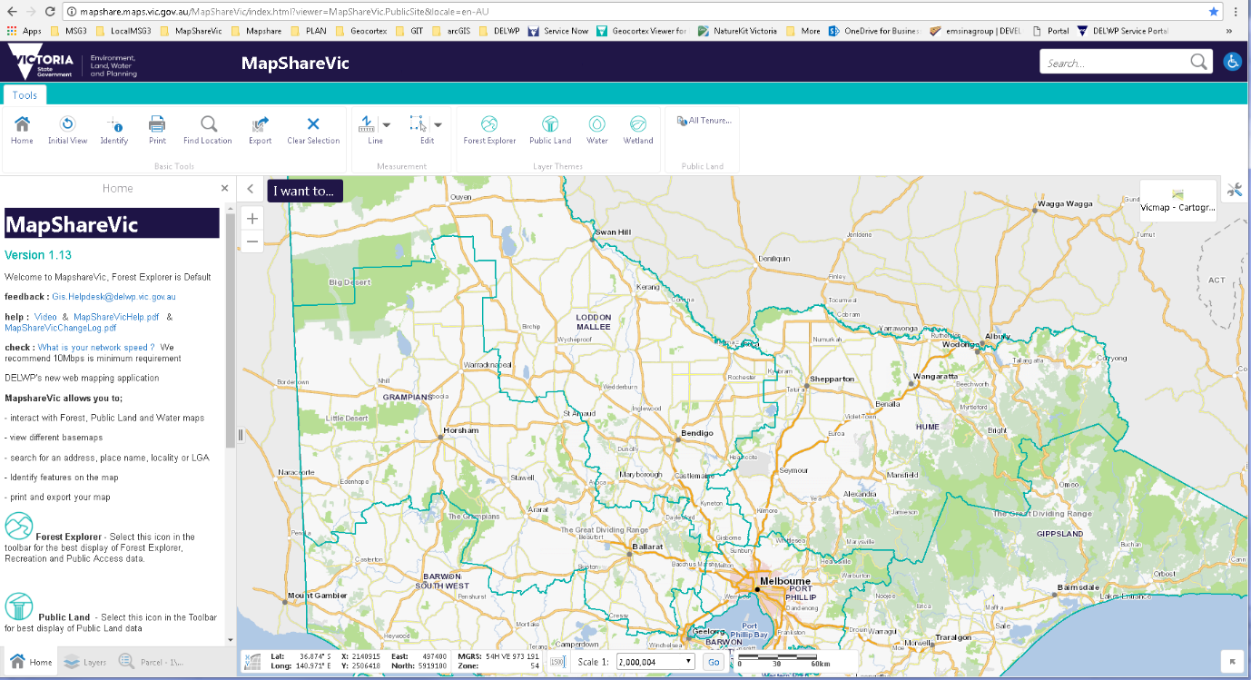

### Specifications

You may see a different view depending if you are browsing using a Desktop, Tablet or Handheld device.

Many factors can influence the performance of this application on your viewer

We recommend

* minimum 10 Mbps network
* Chrome browser
* The latest versions of the browsers should be used. *If old incompatible versions of Internet Explorer, Firefox or Chrome are being used there will be a reduction in performance*

Contents

MapShareVic 1

Overview 1

Specifications 1

Basics 3

Desktop Viewer 3

Home Panel View 3

Tablet Viewer 4

Handheld Viewer 4

Search 5

Global Search 5

Search 1 – Zooms to selected option 5

Search 2 – Displays search results 6

Find Location tool 8

Layer Panel View 9

Layer Action menu 10

Panel Action Menu 11

Layer Panel Action Menu 11

Results Panel Action Menu - 11

Right Click on Map Menu 11

Printing 12

Tablet View Help 13

Display data on the map, when you can’t see it 14

Map Projections 15

Layer name is grey and is not displayed 16

How to measure Areas quickly 19

Change the look of data 20

How to filter your data in the map view 22

FAQ and Known Problems 23

Frequently asked questions 23

Known Problem 25

## Basics

### Desktop Viewer

Below are the main components to MapshareVic: using a Desktop Viewer

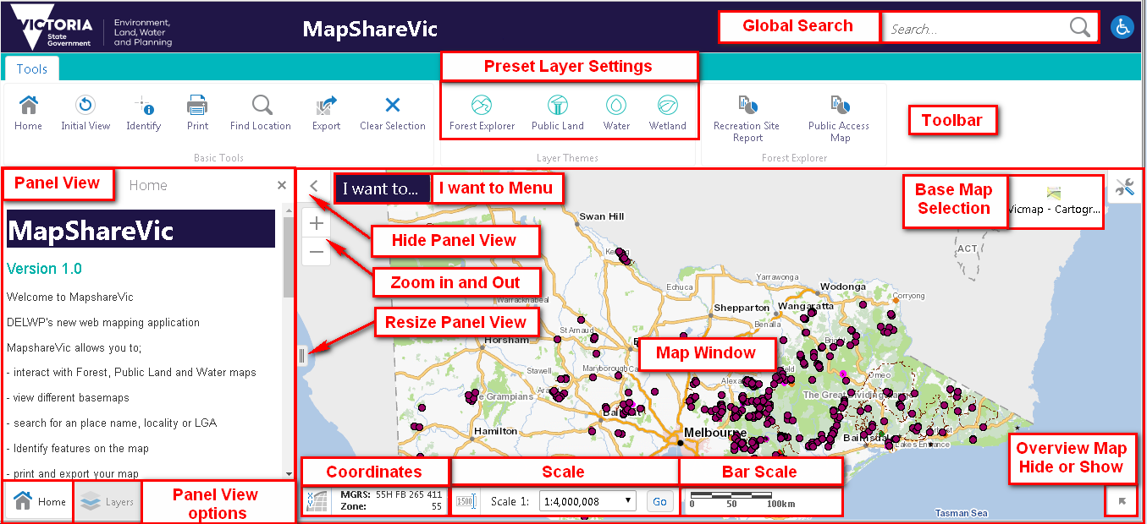

Try each of these components, get familiar with how they work and what they do

Select the XY option to expand the coordinates options for the curser position



Projections

**GDA94** Latitude/Longitude **VicGrid 94** X/Y **MGA Zone 54 and 55** East/North

**MGRS** Military Grid Reference System ( not visible since 25 June 2018 upgrade )

## Home Panel View

The Welcome page or default Panel view is Home, which will give you general web application information, including contact details

### Tablet Viewer

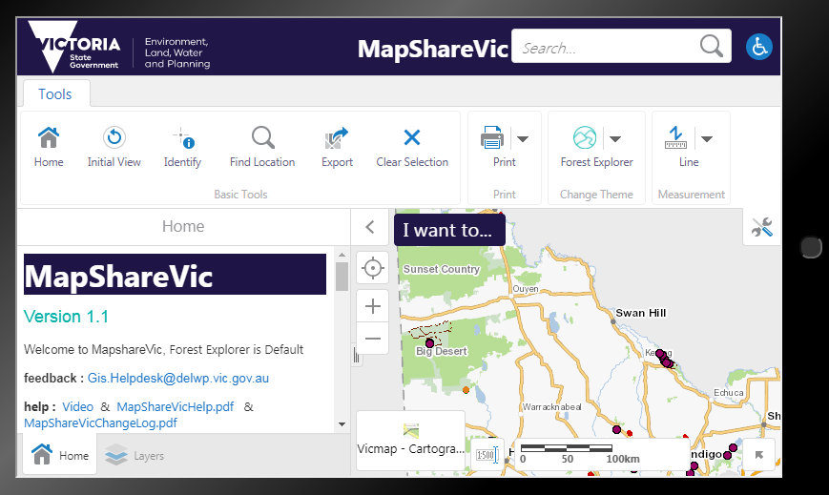

### Handheld Viewer

Toolbars and options are hidden for the best view of the map

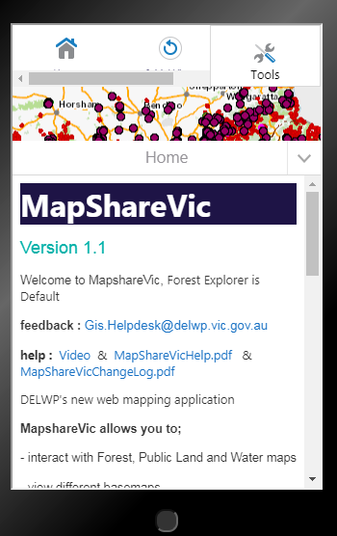 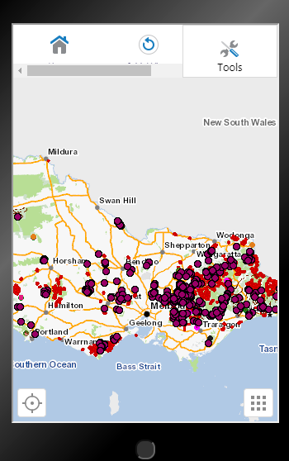 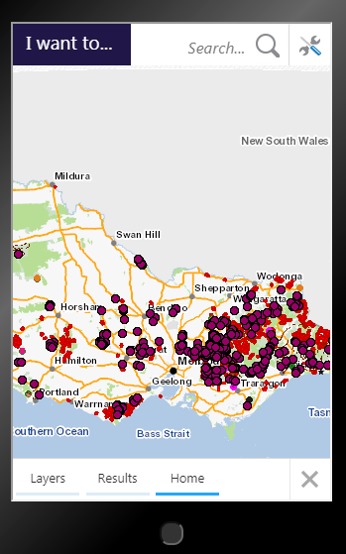

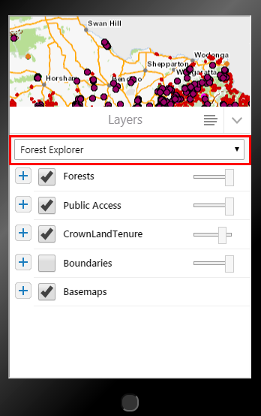

## Search

### Global Search

The Global Search box allows you to search for address/spi/localities/features on the map and can be used in 2 ways, for an immediate zoom to a selection or with a click of the **enter** button the results will be displayed in a Results Panel View for further selection.



1. Search – suggestions given 2. Search – results shown on left panel

for selection

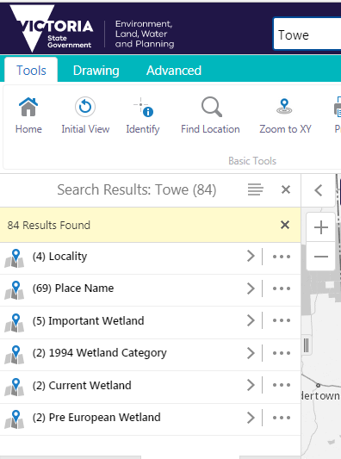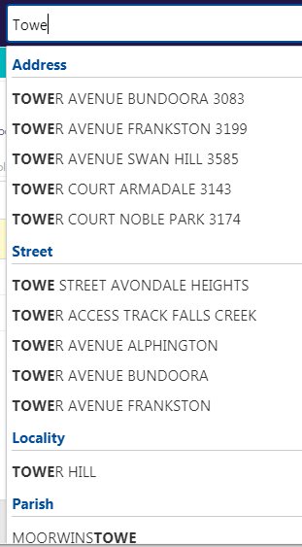

### Search 1 – Zooms to selected option

**Address** *try [ 123 Smith ] [ 123 Smith Port ]*

**Parcel SPI** (Lot/Plan Number) *try [ 1\LP123 ]* **Pnumber** *try [ P123 ]*

**Street** *try [ Smith ] [ Smith C ] [Smith Cre ]*

**Lot on Street** *try [ Lot 4 Smith St ] [ Lot 1 Smith Ave ]*

**Locality** *try [ Wunghnu ] [ Lady ]* **Council** *try [ Moyne ]*

**Postcode** *try [ 321 ]*

**Parish** *try [ Ballarat ] [ Mildura ]*

**Crown Allotment** *try [ Ballarat 15 1a ] allot 15 sec 1a [ Ballarat J ] sec J*

**Property Number** *try [ 12345 Casey ]*

### Search 2 – Displays search results

When you type a word into the Search box and select the **Enter** button, the results start to display in the results list immediately. More items display in the Results List as they are found.

These are now grouped for easier selection of numerous results, click the arrow

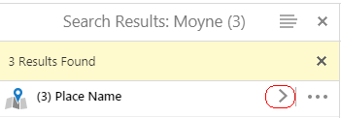

 

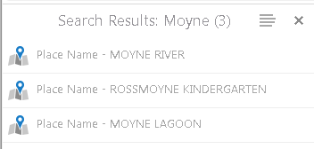 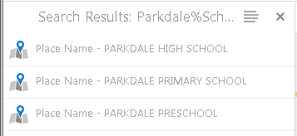

Results. Click on one of the search results and the map will reposition to its location.

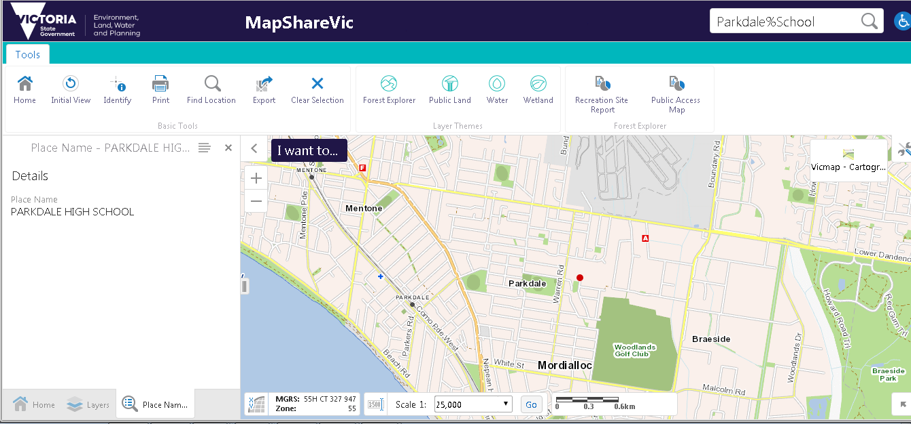

Tablet View

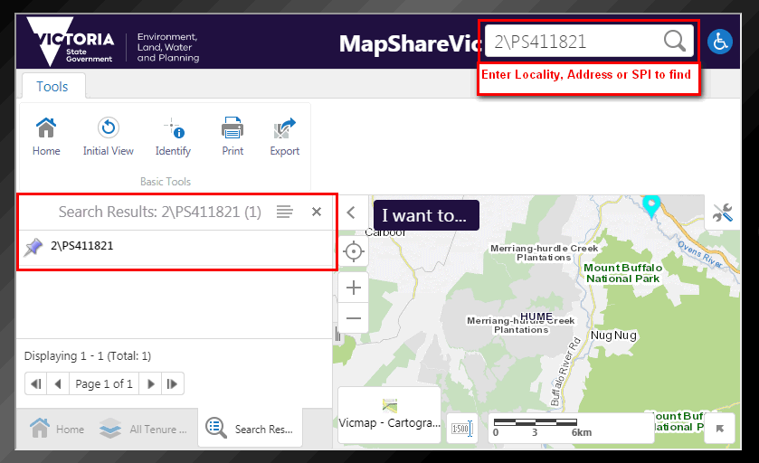

### Find Location tool

Select the Find Location button in the Toolbar 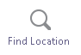

The options will change depending which Theme you are currently in

For Forest Explorer Theme the following options are available

Select or Enter an **option** and then the **OK** button and the map **will automatically zoom** to the location

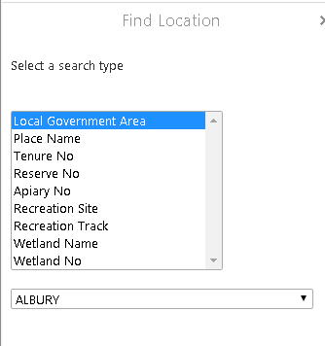



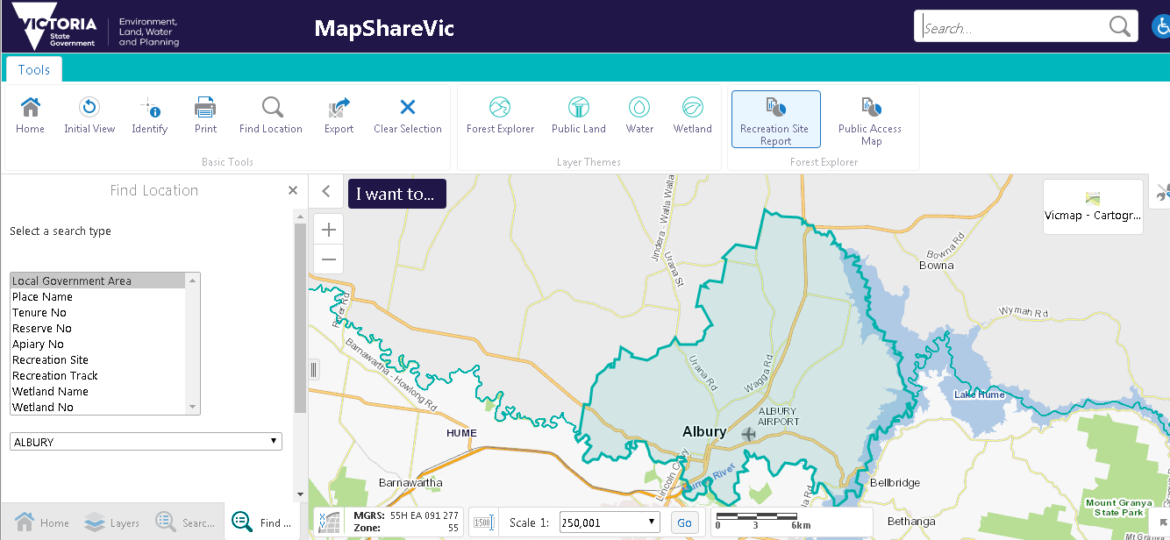

## Layer Panel View

Layer Control This panel displays the spatial layer list. 

From here you can use the check boxes to select the layers you want shown on your map. Some layers have additional Layer action tools to allow you to see the Metadata about the layer.

Below are the components

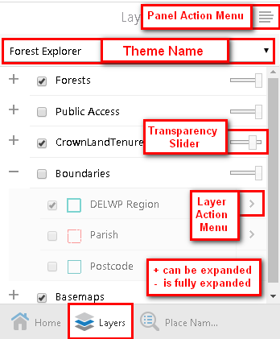

Expand and Contract Layer lists with the **+** and **-**  options

Turn Layers on/off with the Checkboxes.

Use the Transparency slider to view layers below.

Access additional tools with the Panel Action and Layer Action Menus

* Layer Panel Action Menu, displays the legend



Note : Only the Layers with a tick will be displayed in the legend

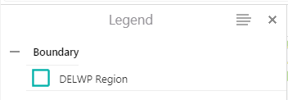

Check the current Theme being displayed on the map

### Layer Action menu

Select the > at the right of the Layer Name to display the Layer Action menu shown below

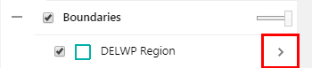

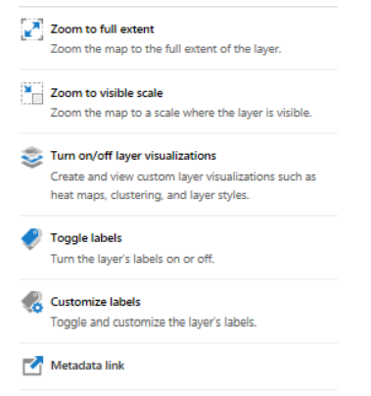

**Zoom to full extent**

Zoom the map to the full extent of the layer.

**Zoom to visible scale**

Zoom the map to a scale where the layer is visible.

**Turn on/off layer visualizations**

Create and view custom layer visualisations such as Heat Maps, Clustering and Layer Styles.

* For an outline only visualization, select white for the fill and then max the transparency

**Toggle labels**

Turn the layer’s labels on or off.

**Customize labels**

Toggle and customise the layer’s labels.

**Metadata link**

Click this Metadata link to view the Metadata about the layer.

## Panel Action Menu

Depending on the Panel View you have active, different menus will appear

### Layer Panel Action Menu



### Results Panel Action Menu -

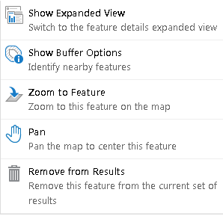

## Right Click on Map Menu

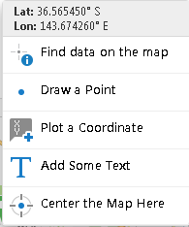

## Printing

There are a number of different Print templates for you to choose from:

**Layout –**

A4 Landscape – DELWP, A3 Landscape – DELWP, A4 Portrait – DELWP, A3 Portrait – DELWP, A4 Portrait – Basic Style, A4 Portrait – Simple

**Output format –**

You can choose a number of different

Output formats – default is PDF, Rtf, Tiff, BMP, Gif, Jpeg, Png, GeoTIFF.

**Resolution –**

You can choose between

Low (96dpi) – Default, Medium (144 dpi), High (216 dpi) or Quality(360dpi).

**Grid –**

You can choose to print your map with a Grid.

None is the default, or choose: VicGrid Latitude/Longitude MGA Zone 54 MGA Zone 55

**Map Scale –**

Current scale is the default, or you can choose Current Extent, or a range of scales based on the Base Map scales.

**Title –**

You can add a Title to your map.

**Lock print preview with map –**

 You can see exactly where the print extent will be with this ticked.

## Tablet View Help

Search for a location



Select Result in the left panel, and the Map will zoom to this location

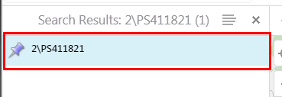

Adjust options for best view of Map

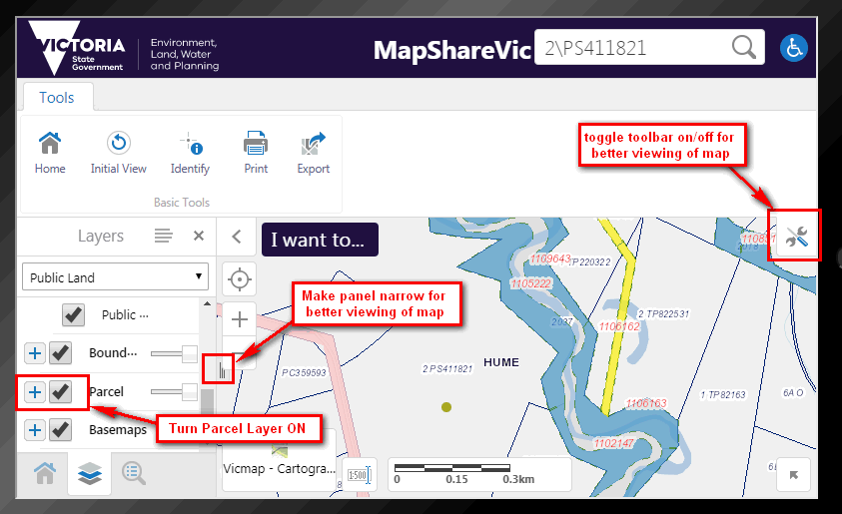

### Display data on the map, when you can’t see it

Expand the  for the Group of Layers you wish to see on the map, then select the arrow 

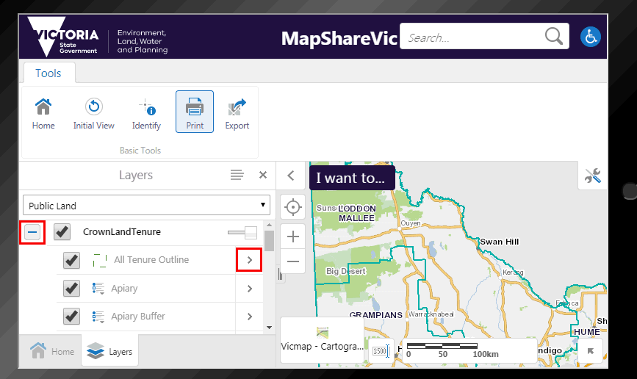

On the next Menu, select  **Zoom to visible scale**

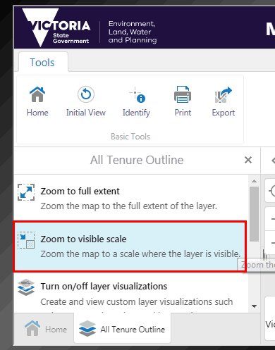

Crown Land Tenure- All Tenure Outline data is now displayed

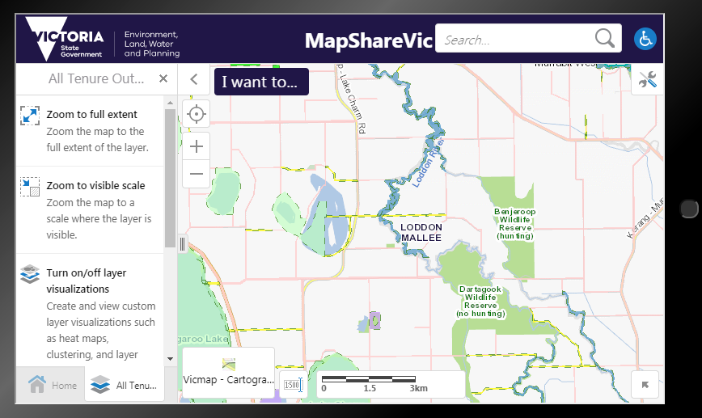

If you still can’t see the data then check for known problems

## Map Projections

The curser position can be shown is several different projections

Select the XY option to expand the coordinates options for the curser position



Projections

**GDA94** Latitude/Longitude **VicGrid 94** X/Y **MGA Zone 54 and 55** East/North

Military Grid Reference System (**MGRS**)

* The Geocentric Datum of Australia 1994 (**GDA94**) is Australia's official geodetic datum.
* The **VicGrid94** projection has been chosen as the projection of choice as it is the most accurate projection with minimal distortions for the state of Victoria mapping applications.
* The Map Grid of Australia 1994 **(MGA)** is the standard map projection associated with GDA94.
* The Military Grid Reference System  (**MGRS**) is the geocoordinate standard used by NATO militaries for locating points on the earth.

## Layer name is grey and is not displayed

Some Layers will only display at certain scale range, this is to optimise the speed of the display of the map for the user.

If the Layer name is grey, then this data is not displayed even if it is ticked, because it is outside its scale range.

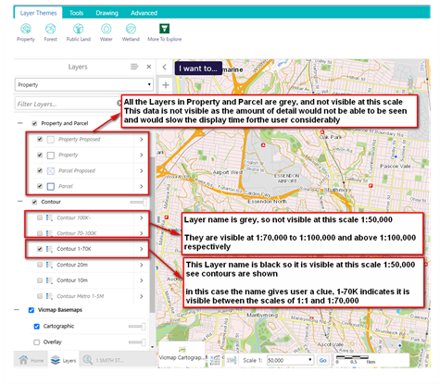

To display the data on the map from the layer name in *grey italics*

Select the > on the required layer, ***Contour 70-100K*** and select the **Zoom to visible scale** option which will zoom the map to 1:100,000

 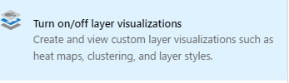

The Layer name changes to black



Contours are displayed at 1:100,000 using the **Layer Contour 70-100K** , which is now black

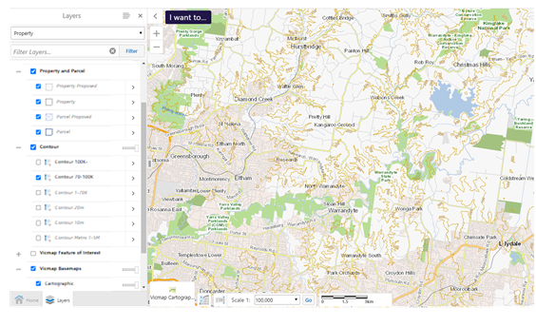

Select the > on the required layer, ***Parcel*,** 

and select the **Zoom to visible scale** option which will zoom the map to 1:25,000 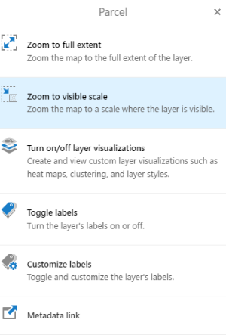

Parcels are displayed at 1:25,000 and the Layer name **Parcel** is now black

The contours are also displayed, using the **Contour 1-70K**, which is black

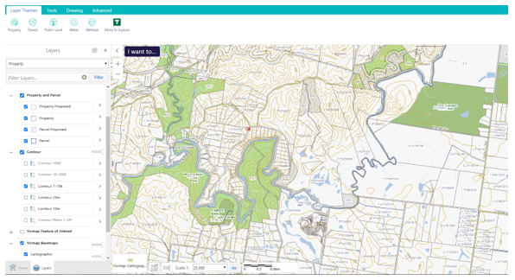

## How to measure Areas quickly

* Select the required feature with the Identify tool

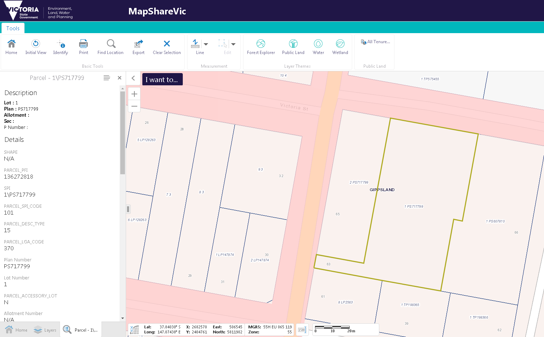

* Select the Panel Action Menu in the upper right hand side of the panel



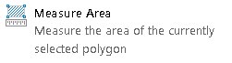

* Select the Measurement option

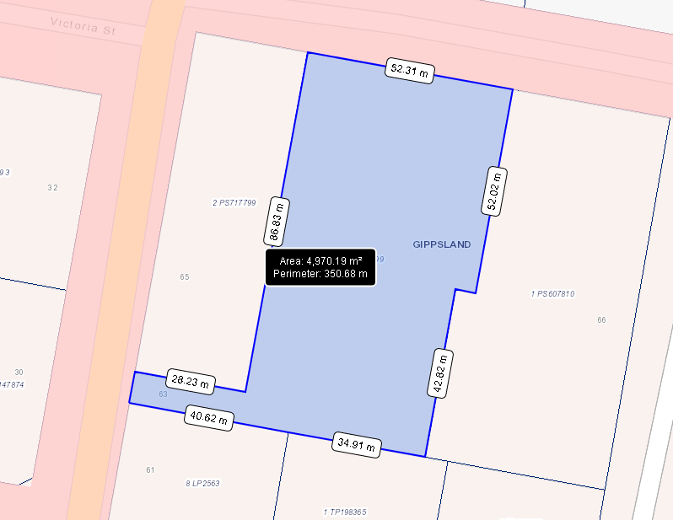

## Change the look of data

The capability to style the vector layers containing lines, points or polygons is available - including parcel boundaries as shown in the image below...

Select the > on the required layer,



and then **Turn on/off layer Visualizations**

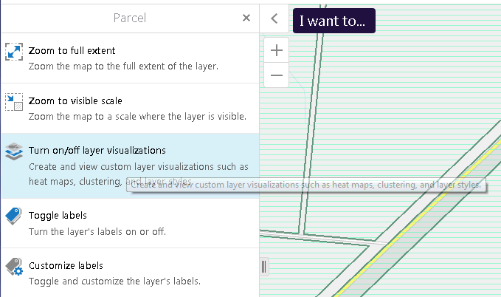

Options available

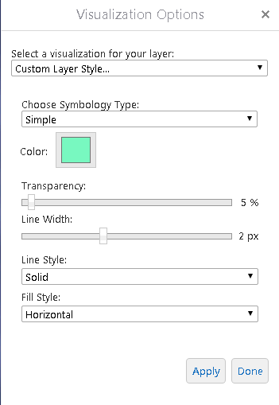

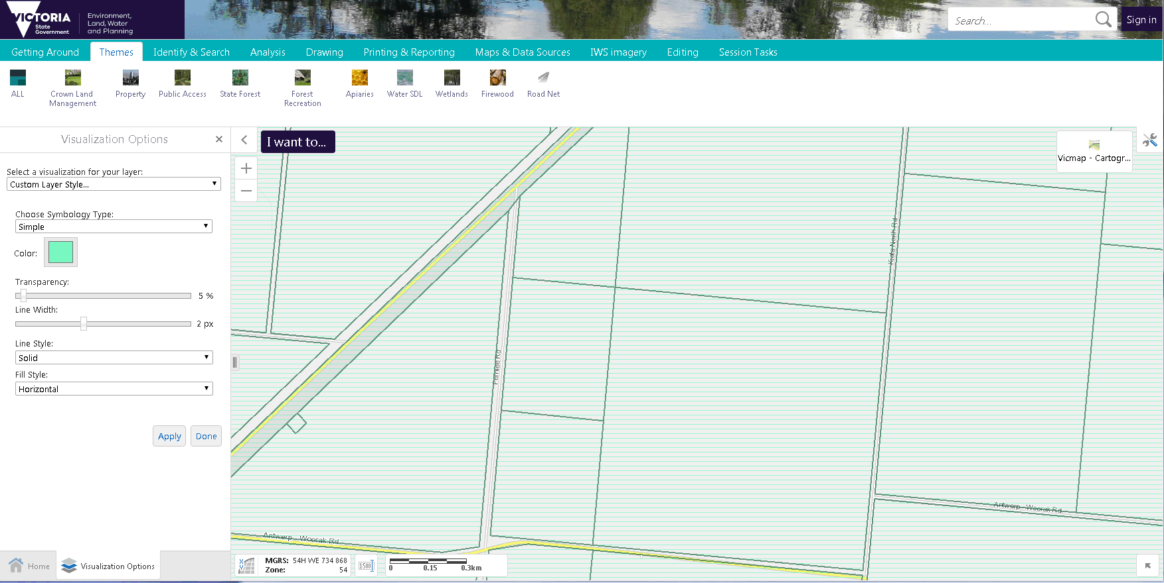

For a transparent fill choose the opacity required in the Colour option

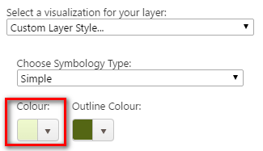 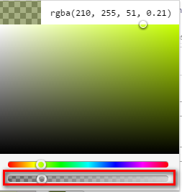

Simply select **None** to go back to the default style

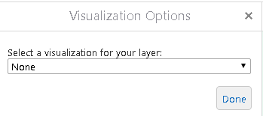

## How to filter your data in the map view

You can filter any data layer using the fields available to display the information you require

The filter tool is located in the Advanced tab, see the example below to show how it works

* To display only the Wildfire History after 2010 select the **Advanced** tab, then **Filter** tool
* In the form that appears, select the Layer **Wildfire History**, **Season > 2010** as shown below.
* You can see that only the Wildfires that occurred after 2010 is now displayed.
* To return to the normal display, just select the Clear button

Map View of Wildfire Layer with Filter of all data after 2010

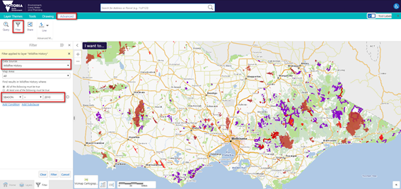

Map View of Wildfire Layer with no Filter

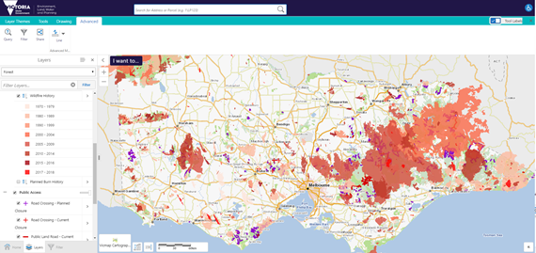

## FAQ and Known Problems

### Frequently asked questions

#### How do I display the Legend

* Select the button  at the top right hand corner of the Layer Panel
* Select **Show Legend** 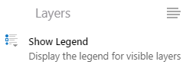
* The Legend Panel will display showing only those layers that are currently visible



Or select the **Show Legend** option from the **I want to..**. menu 

Or select the S**how Legend** toolbar button on the **Tools** tab

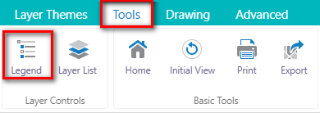

#### How do I add my exported data to Avenza

Since the Georeferenced option is not available for exporting as a pdf.

Avenza PDF Maps consumes **GeoTIFFs** better than GeoPDFs. The software when consuming a GeoPDF renders it to a GeoTIFF.

In MapShareVic, export the image as a **GeoTIFF**, (which does not require the Georeferenced option ticked, as by its format it is automatically georeferenced)

Load into your Avenza PDF Maps.

#### How do I convert Co-ordinates

* Select the XY  co-ordinates at the bottom right corner of map
* Different Projection co-ordinate information will appear

To convert coordinates use the following online resource

<http://tool-online.com/en/coordinate-converter.php>

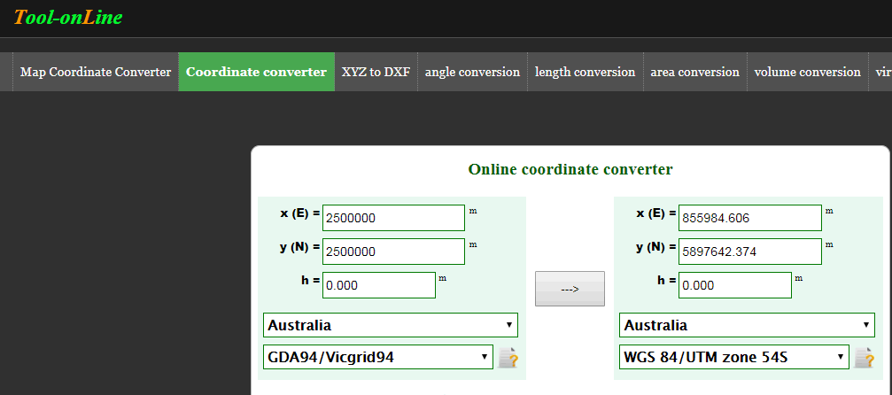

#### Vicmap Aerial Imagery not displaying

This basemap does not display below 1:800 scale. This data is made available for us to use as is, and we can not change the display properties.

1:800 und below

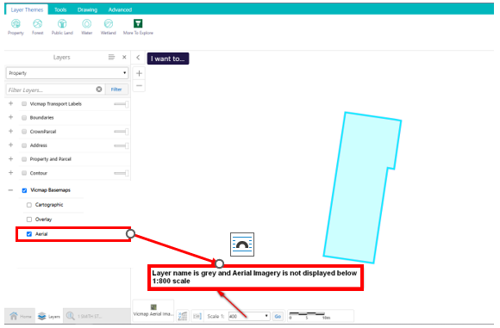

Change the scale to 1:800 and the Imagery will display

1:800 and above

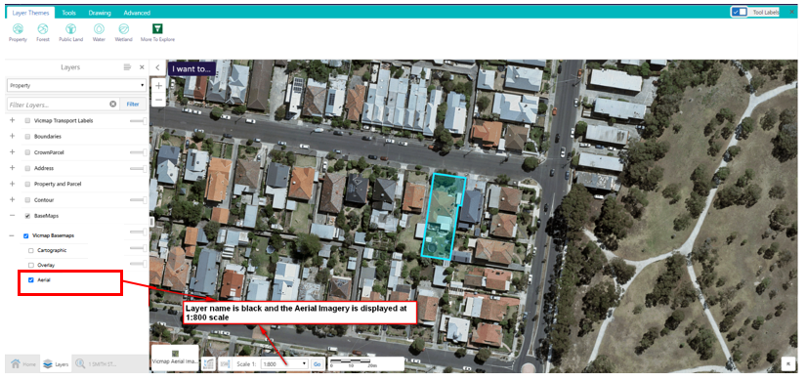

### Known Problem

#### The data is not displaying

There is a known problem that when displaying more than 7 layers in the same mapservice, data disappears.

If you are having problems displaying data, you may require to untick/tick the layers until only a maximum of 6 layers in single folder are ticked or until the data required is displayed on the map.