DEECA Gender Equality Progress Summary Report

Summary of DEECA’s Gender Equality Action Plan 2023 progress report

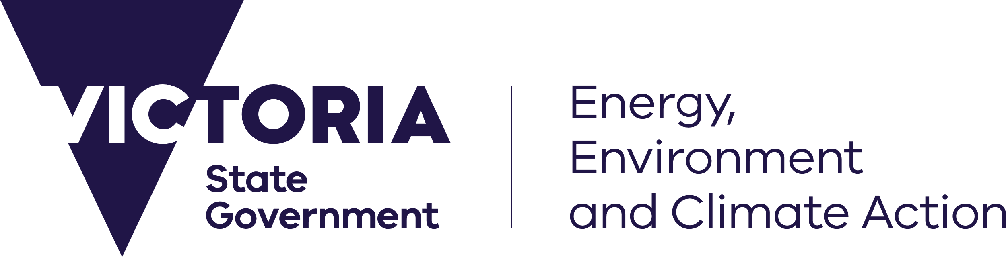



deeca.vic.gov.au

# Introduction

deeca.vic.gov.au

In February 2024, the Department of Energy, Environment, and Climate Action achieved a significant milestone, submitting our first gender equality progress report to the Commission for Gender Equality in the Public Sector. We have since received recognition from the Commissioner that the report complied with all requirements, and we are pleased to share the findings and collective achievements made as an organisation.

Our journey towards gender equity goes beyond meeting regulatory requirements. It is a deeply rooted commitment to creating a workplace where everyone, regardless of gender, feels valued, respected, and empowered to reach their full potential. While recognising our progress, the department acknowledges that important challenges remain for us to overcome. We will continue to reach beyond regulatory standards to ensure everyone, including people who identify as women from intersectional backgrounds and our gender-diverse staff, have equal access to support and advancement opportunities.

# Summary of Findings

DEECA’s Pay Gap Action Toolkit provides a solid foundation for the success of gender pay parity actions. DEECA has maintained a 0% gender pay gap for two consecutive years, however we can continue to address women's economic security by:

* Carrying out a pay gap audit annually with a target of less than 2%.
* Enhancing financial knowledge and building awareness of the impacts of gender on economic security through education sessions for staff.

To help maintain a 0% gender pay gap, we are committed to achieving gender balance at all levels and areas of the organisation. Systemic barriers have been identified in areas of the organisation with lower workforce participation rates of women. Actions to address this include:

* Providing job shadowing and mentoring opportunities for professional development.
* Offering learning opportunities for all staff involved in recruitment to ensure fair, inclusive, and equitable recruitment practices.

As a result of these actions, we recorded gender parity among new recruits. In addition, we recorded parity across the aspects of career progression, including promotion, appointments, career development training, and higher duties and secondment assignments. There has also been a significant increase in the proportion of applicants and appointees identifying as women to emergency management roles in Bushfire and Forest Services.

Gender inequity in the workplace exacerbates sexual harassment, especially when combined with other forms of discrimination. Formal reports of sexual harassment in the department have remained low compared to 3% of staff indicating in the People Matter Survey that they have experienced sexual harassment in the last 12 months. Our continued focus is to create a workplace where every employee feels empowered and safe to report all forms of inappropriate behaviour. Actions to address this include:

* Launching the *Talk to Us* hotline for staff to confidentially and anonymously report inappropriate workplace behaviour, including sexual harassment.
* People leader training on leading safe and respectful teams to address mindsets that perpetuate gender inequality.
* Launching the "Call it out. Tell Someone. Report it." communications campaign, to promote a workplace culture of speaking up against negative behaviours.

To date, these actions have significantly increased staff attendance and engagement with [Safe and](https://delwpvicgovau.sharepoint.com/Campaigns/Safe-and-respectful-workplace/Pages/Making-DELWP-a-safe-and-respectful-workplace.aspx) Respectful Workplaces training. This indicates a growing awareness and proactive culture for addressing workplace sexual harassment in the department

# Gender Impact Assessment

Our department completed 46 Gender Impact Assessments (GIAs) as part of the 2022-23 and 2023-24 State budget processes. Across these budget processes, the department increased our assessment submission rate from 12% to 100%.

# Looking Forward

We are committed to progressing gender equity and providing all staff with a safe and inclusive workplace.  
It is a privilege to reflect on the work and achievements that have been accomplished so far, and we have established a robust position to continue accelerating our progress. We remain committed to implementing the Gender Equality Action Plan, conducting regular gender pay audits, and adopting an intersectional gendered lens in Gender Impact Assessments and decision-making. I invite you to review this report and discuss with peers, teams and others how we can advance our gender equality efforts.



John Bradley, Secretary

**Workforce Gender Equality Indicators**

# The *Gender Equality Act 2020* sets out 7 workplace gender equality indicators to drive actions for gender equality. These indicators represent key areas where workplace gender inequality persists in the workforce and where action is needed.

Over time, these indicators aim to increase women's economic security, increase workforce participation rates and improve health and well-being outcomes.

1

Gender composition of all levels of the workforce

2

Gender composition of governing bodies

We will continue working towards achieving intersectional gender parity at all levels and ensuring that all individuals have equal opportunities for growth and advancement within our department,

1.5% increase of senior and executive leadership identifying as a woman since 2021.



This is a 4.4% increase since 2021.

of employees identify as women (2023).

53%



Women

Men

2021

2023

Increased representation of women on DEECA‘s governing board, increased from 38% in 2021 to 50% in 2023.

3

Gender pay equity

0

%

Gender pay gap reported for two consecutive years.

We are enhancing our collection and analysis of intersectional pay equity data.

The gender pay gap refers to difference between the average or median pay of different genders, not a comparison of like roles.

4

Workplace sexual harassment

In 2023, **3%** of People Matter Survey respondents **experienced sexual harassment** in the last 12 months. There has been no change since 2021.

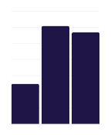

Safe and Respectful Workplace sessions have increased as part of proactive efforts to ensure we have a zero-tolerance for sexual harassment in our workplaces.

61

The below metrics demonstrate our progress towards reducing gender segregation in Bushfire and Forest Services (BFS), a 'hot spot' for gender segregation at DEECA.

57

20%

increase of seasonal firefighter applications from women (2022 to 2023).

8% increase of women in emergency roles in BFS (2019 - 2022).

10% increase of women in strategic leadership roles in BFS.

DEECA Target:

Increase the proportion of women in emergency management roles.

25

2021

2022

2023

5

Recruitment and promotion

52

%

of new recruits identified as women in 2023.

VPS5 classification had the largest increase of recruits identifying as women (9% increase between 2021 - 2023).

In 2023...

7

Leave and flexibility

We prioritise accessibility and support by making policies on family violence leave, flexible work, and caring responsibilities easily available through our intranet.

**In 2023…**

Women were successful in 56% of promotion opportunities.

60% of staff who engaged in career development training identified as women.

25% of staff accessed careers leave

100% of staff have at accessed at least one occurrence of formal flexible work.

55% of higher duty and internal secondments were awarded to women.

© The State of Victoria Department of Energy, Environment and Climate Action 2024.

**ISBN** 978-1-76136-934-6 **(pdf)**

6

Gendered work segregation



We acknowledge Victorian Traditional Owners and their Elders past and present as the original custodians of Victoria’s land and waters and commit to genuinely partnering with them and Victoria’s Aboriginal community to progress their aspirations.

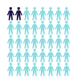

In 2023, 5% of People Matter Survey respondents experienced discrimination related to their gender identity. This is a decrease from 15% in 2021.