**Income Tax exemptions for Not-for-profit (NFP) organisations**

**Information for Victorian Crown land reserve committees of management (Voluntary CoMs)**

**Prepared by Michael Gourlay,** **Project Manager (Committees of Manager) Department of Energy, Environment and Climate Action (DEECA). 12 09 24**

**Introduction**

A number of Victorian Crown land reserve committees of management (Voluntary CoMs) received a letter from the Australian Taxation Office (ATO) during May/June 2024. The letters requests CoMs to go through a detailed process to establish eligibility for exemption from income tax for the 23-24 financial year, due 31 October 24.

See Appendix A for a sample excerpt of the ATO letter – Not-for-profit (NFP) income tax exemption self-review process – (also referred to below as the “ATO Income Tax letter”).

This information sheet is designed to assist those CoMs that received the ATO Income Tax letter in deciding on the most appropriate response.

It will also assist members of CoMs that didn’t receive the letter in the name of the CoM but did receive the letter as a member of an Incorporated Association (IA) that is a tenant or user group of a CoM reserve.

For reasons explained below, the ATO’s tagging of the “entity type” of a CoM’s Australian Business Number (ABN) is a key factor determining which CoMs got the letter (and which CoMs didn’t) and the nature of the response for CoMs to consider.

**Types of Incorporation (and the distinction between “Not-for-profit” and “charitable”)**

It is also important to note the different types of incorporation of Voluntary CoMs. As explained on the [committees of management section of the DEECA website](https://www.deeca.vic.gov.au/boards-and-governance/committees-of-management):

* Voluntary Crown land reserve committees of management (Voluntary CoMs) are all *appointed* as Crown land reserve managers through the *Crown Land (Reserves) Act 1978* (CLRA) but the *basis of their incorporation as organisations* may vary.
* The majority of Voluntary CoMs (around 85%) are incorporated through the CLRA, with a small number currently unincorporated and awaiting incorporation through the CLRA. These are referred to below as “CLRA Incorporated CoMs” and are “Public/State Government Entities”.
* The bulk of the remaining Voluntary CoMs are Incorporated Associations (IA) governed by the *Associations Incorporation Reform Act 2012* and regulated by Consumer Affairs Victoria (CAV). There are also some that are Companies Limited by Guarantee (CLG) governed by the Corporations Act 2001 (Cth) or Cooperatives (governed by the Co-operatives National Law Application Act 2013).

All of these entities are, in the general use of the term, not-for-profit organisations (NFPs) but CLRA Incorporated CoMs are “Public/State Government Entities” whereas IAs are known as “non-government” NFPs. When the ATO references “NFPs” they are usually referring to IA NFPs.

In addition, as explained in more detail in Appendix E, while some NFPs are classified by the ATO as an official “charitable organisation”, an organisation can be an NFP but not classified as a charity. NFPs that meet the legal definition of a charity are registered with the Australian Charities and Not-for-profits Commission (ACNC) and endorsed by the ATO to be income tax exempt.

**The importance of ABN “Entity Type” tagging**

The details of Australian Business Numbers (ABNs) can be found through “ABN Look-Up” at <https://abr.business.gov.au/>.

There are two key ABN “entity type” tags relevant to the ATO Income Tax letter for Voluntary CoMs, “State Government Entity” and “Other Incorporated Entity”.

* “State Government Entity” is the appropriate ABN entity type tag for CLRA Incorporated Voluntary CoMs.
* “Other Incorporated Entity” is the appropriate ABN entity type for IAs.

CoMs with only a “State Government Entity” tagged ABN (and no other/second ABN) will not have been sent the ATO letter about income tax exemption. This is because state government entities are automatically exempt from income tax.

CoMs with an “Other Organisational Entity” tagged ABN (and who are not a *registered charitable organisation*) will have received the ATO Income Tax letter. Note this includes CLRA Incorporated CoMs who either by mistake or for some other reason have one or more ABNs tagged as “Other Incorporated Entity”. It also explains why the IA user groups on some reserves received the ATO letter but the CLRA Incorporated Voluntary CoM itself didn’t.

Significant confusion regarding the ATO Income Tax letter has occurred where CoMs have an ABN with an incorrect “entity type” tag on their ABN and/or have multiple ABNs with different “entity type” tags.

**Key Messages Summary**

1. Under normal circumstances Crown land reserve CoMs are not required to pay income tax. It is not envisaged that any Crown land reserve committees of management (Voluntary CoMs) will be required to pay income tax.
2. Rather, the ATO letter/process seeks some key facts about organisations to establish that they are indeed eligible for exemption from income tax.
3. Significant confusion regarding the ATO Income Tax letter has occurred where CoMs have an Australian Business Number (ABN) with an incorrect “entity type” tag on their ABN and/or have multiple ABNs with different “entity type” tags.

**Incorporated Associations**

The intended main target of the ATO Income Tax letter is Incorporated Association (IAs) that are not officially registered charitable organisations (non-charity NFPs). This includes Voluntary CoMs that are IAs and IA user groups operating on reserves managed by CLRA Incorporated CoMs.

For these IAs, the ATO instructions for response in the Income Tax letter make perfect sense and are easy to follow. Hitting the heading “How to access and lodge the NFP self-review return“ via <http://www.ato.gov.au/NFPTaxExempt> (see Appendices A and B) will lead to a page that explains the process, including a link to an “NFP self-review guide” at <https://www.ato.gov.au/businesses-and-organisations/not-for-profit-organisations/statements-and-returns/how-to-prepare-a-nfp-self-review-return>.

IAs that are registered charities (charity NFPs) will not have received the ATO Income Tax letter and are not required to engage in any income tax exemption process with the ATO – as registered charities they are automatically exempt from income tax.

**CLRA Incorporated CoMs**

CLRA Incorporated CoMs with the correct ABN “entity type” tag of “State Government Entity” will not have received the ATO Income Tax letter and are not required to engage in any income tax exemption process with the ATO – as state government entities they are automatically exempt from income tax.

CLRA Incorporated CoMs with an incorrect ABN “entity type” tag (“Other Incorporated Entity” rather than “State Government Entity”) and CLRA Incorporated CoMs with multiple ABNs (including at least one with an “Other Incorporated Entity” ABN tag) will have received the ATO Income Tax letter. The options for responding to the ATO Income Tax letter will vary depending on circumstances. See further below under “Suggested Actions”.

If CLRA Incorporated CoMs with an “Other Incorporated Entity” ABN attempt to complete the NFP self-review, they will encounter difficulties because the questions asked in the review process are related to IAs and don’t “fit’ with organisations such as CLRA Incorporated CoMs that are public/state government entities.

**Grant eligibility issues associated with ABN entity type tags**

The issue of some CLRA Incorporated CoMs being denied access to some grant application processes due to having a “State Government Entity” tagged ABN is discussed in Appendix F.

**Suggested Actions for CoMs who have received the ATO letter (and believe they shouldn’t have)**

1. Check your CoMs Australian Business Number (ABN) via the search on the “ABN Look-up” site <https://abr.business.gov.au/>.
2. Note: if your CoM received the ATO Income Tax letter the ABN which triggered the letter will be evident as the “Client No.” listed on the top right-hand side of the letter.
3. In addition to searching via a specific ABN number, do a search using key elements of your CoM’s name to establish if there are multiple ABNs associated with your CoM. It is not uncommon for a CoM to have two ABNs, one of which is no longer used.
4. Take note of the “entity tag” for your CoMs ABN(s).

1. In the case of multiple ABNs, note which one is the “main” one actively used by your CoM. In most cases of multiple ABNs, only one of the ABNs will be in active use and the process to tidy up ABN listings with the ATO will be relatively simple. In situations where a CoM has multiple ABNs and actively uses more than one, the process will be more complicated (see also 8. below).
2. If there are changes required to ensure your CoMs ABN has the correct “entity type” tag, ensure that your CoMs “ATO Contact Person” is up to date (see Appendix C) and then initiate contact with the Australian Taxation Office (ATO) to make the necessary changes (see Appendix D).
3. For CLRA Incorporated CoMs, once it is established with the ATO that your only ABN is correctly tagged as “State Government Entity” the ATO Income Tax letter process becomes redundant. You will not need to complete this year’s process for the 2023-24 financial year and you will not receive any requests in future years to prove your eligibility for income tax exemption.

Example 1

CLRA Incorporated CoM has two ABNs, one is tagged “State Government Entity” and the other is tagged “Other Incorporated Entity”. The CoM has only ever used the State Government Entity ABN and nobody knows when/why or how the other ABN was established. The CoM received the letter because of the “Other Incorporated Entity” ABN.

Solution: Contact the ATO and have the second “Other Incorporated Entity” ABN deleted (made Inactive) leaving the CoM with just one ABN tagged “State Government Entity.”

Example 2:

CLRA Incorporated CoM has one ABN tagged mistakenly as “Other Incorporated Entity” when it should be “State Government Entity”.

Solution: Contact the ATO and have the ABN entity type tag changed to “State Government Entity.”

1. In situations where a CLRA Incorporated CoM has multiple ABNs, including at least one tagged “Other Incorporated Entity” that is actively used, the options for responding to the ATO Income Tax letter will vary depending on circumstances. Any CoM in this situation is welcome to contact Michael Gourlay, DEECA Project Manager (Committees of Management) for further information.
2. Some Restricted Crown Grant Trusts (RCGT) that manage one or more Crown land reserves – these are similar in some ways to CoMs but have a different legal basis of incorporation – will have received the ATO Income Tax letter. The ABN “entity type” for RCGTs may include “Trust” or “Other Trust”. For RCGTs, the options for responding to the ATO Income Tax letter will vary depending on circumstances. Any RCGT in this situation is welcome to contact Michael Gourlay, DEECA Program Manager (Committees of Manager) for further information.
3. CoMs that are an incorporated association (IA) and who are not a *registered charitable organisation* (see further in Appendix E) are the intended target group of the ATO Income Tax letter. For IAs, the ATO instructions for response in the letter make perfect sense and are easy to follow. Selecting the heading “How to access and lodge the NFP self-review return“ via <http://www.ato.gov.au/NFPTaxExempt> (see Appendices A and B) will lead to a page that explains the process, including a link to an “NFP self-review guide” at <https://www.ato.gov.au/businesses-and-organisations/not-for-profit-organisations/statements-and-returns/how-to-prepare-a-nfp-self-review-return>.
4. Note: Relating to 8. Above, if CLRA Incorporated CoMs with an “Other Incorporated Entity” ABN attempt to complete the NFP self-review, they will encounter difficulties because the questions asked in the review process are related to incorporated associations and don’t “fit’ with organisations such as CLRA Incorporated CoMs that are public entities.
5. The issue of some CLRA Incorporated CoMs being denied access to some grant application process due to having a “State Government Entity” tagged ABN is discussed in Appendix F.

**DEECA Contact for further information:**

Michael Gourlay, Project Manager Committees of Management

Email: [michael.gourlay@deeca.vic.gov.au](mailto:michael.gourlay@deeca.vic.gov.au)

Phone: 0404 255 317

**Appendix A: Excerpt from the ATO Income Tax letter**

The letter includes a “Client ID” which is the ABN number that has triggered the sending of the letter.

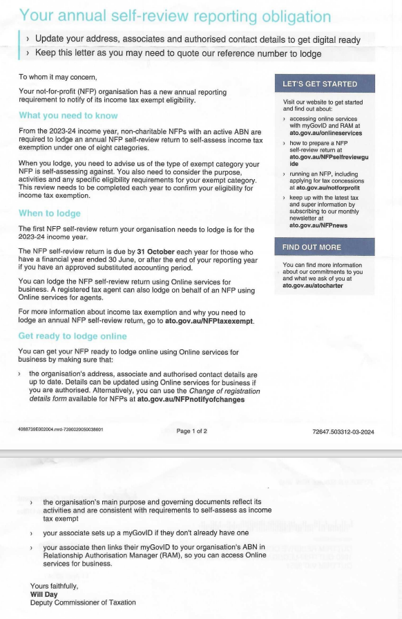

**Appendix B Key ATO links for information about the NFP self-review return**

The ATO Income Tax letter gives the following address as the key link for information:

<http://www.ato.gov.au/NFPTaxExempt>

This link takes you to a page with headings including “Who needs to lodge” and “Who doesn’t need to lodge”.

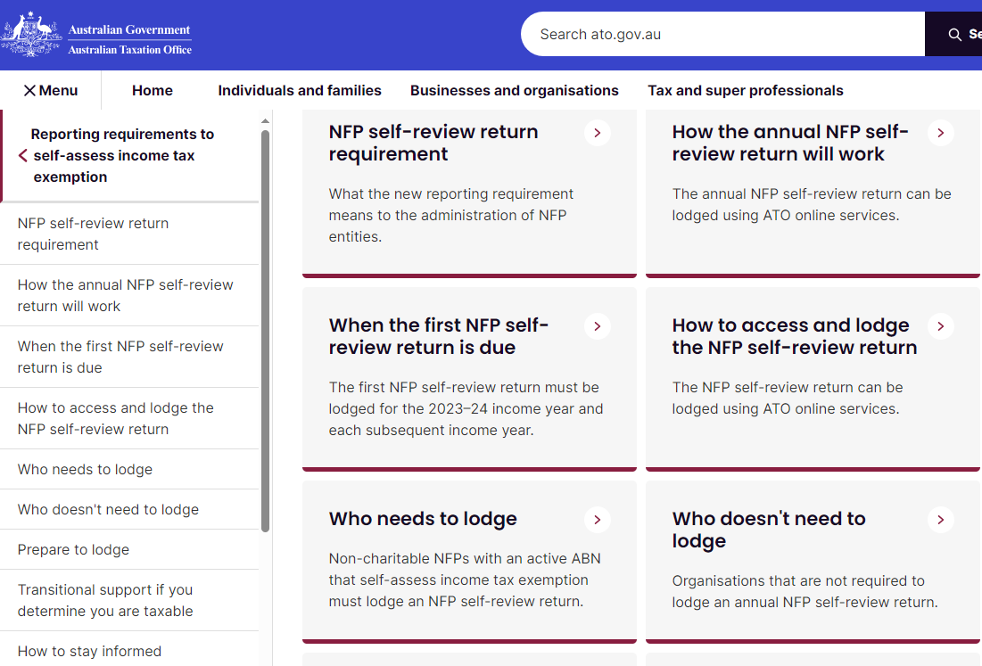

**Appendix C Ensuring your CoMs ATO “Associate” and/or Authorised Contact” details are up to date.**

In making changes or discussing any aspect of ATO related matters, the ATO has a system for designating “Associates” and “Authorised Contacts” and ensuring that communication is being undertaken by an appropriate person (Associate or Authorised Contact).

The ATO Associate is the key contact to establish and get 100% right and up to date as the Associate can then nominate other “Authorised Contacts”.

It is not uncommon for a CoMs ATO “Associate” and/or “Authorised Contact” to be out of date and need updating.

The ATO Income Tax letter gives the following address as the key link for information when you need to make changes:

<http://www.ato.gov.au/NFPnotifyofchanges>

Scrolling down from this link you will see a reference to a section on “Who can notify us of changes?” with details of how to appoint a new ATO Associate via the specific paper form NAT 2943.

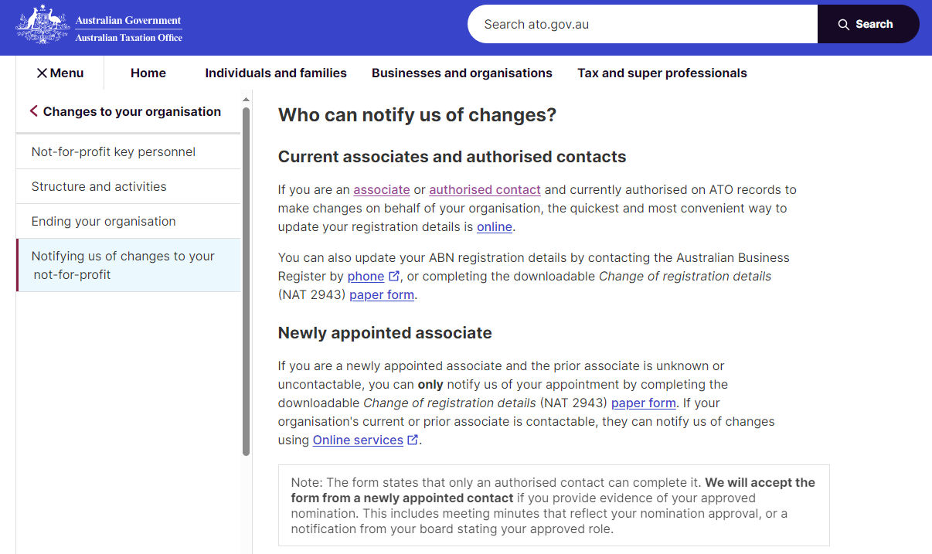

**Appendix D Making ABN changes through the Australian Business Register**

Once your ATO Associate and Authorised Contacts are up to date (see Appendix C) the process to make changes to your ABN is relatively simple. In additional to on-line processes available through <https://www.abr.gov.au/> you can contact the ABR by phone.

**Appendix E: Not-for-profits (NFPs) and officially defined charitable organisations**

While some organisations are classified as not-for-profit (NFP) *and* an official “charitable organisation”, an organisation can be an NFP but not classified as a charity.

NFPs that meet the legal definition of a charity are registered with the Australian Charities and Not-for-profits Commission (ACNC) and endorsed by the ATO to be income tax exempt. These charity NFPs will not have been sent the ATO Income Tax letter.

Incorporated associations (IAs) that are not officially registered charitable organisations with the ACNC will have been sent the ATO Tax Letter.

Note: By definition, a CLRA Incorporated “State Government Entity” CoM – although it is an NFP organisation – cannot also be defined as a charity.

See the ACNC site at <https://www.acnc.gov.au/> for further background on NFPs and charities.

**Appendix F: Note on when a grant application is denied because of having a “State Government Entity" tagged ABN**

Some CLRA Incorporated CoMs have reported that they have been denied access to a grant application process because they have a “State Government Entity” tagged ABN and the grant round is designed for “Not-for-profits”.

This has led some CLRA Incorporated CoMs to consider gaining an additional ABN and/or changing their ABN tag so that they have an “Other Incorporated Entity” ABN” to use for these grant rounds.

Sometimes, the exclusion of a CLRA Incorporated CoM from a given grant round is due to a misunderstanding by the funding body of the nature of the CoM (i.e. CLRA Incorporated CoMs are “not-for-profit”) and/or inadvertent shortcomings of the application forms (asking for an Incorporated Association Incorporation Registration Number, which incorporated associations will have but CLRA Incorporated CoMs will not have)

Many funding bodies are familiar with Incorporated Associations as the standard type of “not-for-profit” organisation. Incorporation as a Crown land reserve CoM through DEECA and the CLRA is very “niche” and not well understood outside of those who are involved with Crown land.

Sometimes, once the nature of CLRA Incorporated CoMs are explained to funding bodies, they are deemed eligible for funding along with other not-for-profits.

If your CoM has had experience with being denied access to a grant opportunity due to having a “State Government Entity” tagged ABN, please contact DEECA staff Michael Gourlay with the details.

Michael Gourlay, Program Manager Committees of Management

Email: [michael.gourlay@deeca.vic.gov.au](mailto:michael.gourlay@deeca.vic.gov.au)

Phone: 0404 255 317